AWS VIRTUAL PRIVATE CLOUD
Agenda
- Introduction to VPC
- Features of VPC
- Benefits of Using AWS VPC
- AWS VPC Architecture
- VPC Components
- Networking Concepts
- Use Cases of AWS VPC
- Creating Custom VPC
Introduction to VPC:
Amazon Virtual Private Cloud (VPC) can be considered a private cloud within the AWS cloud, providing a logically isolated network environment. It allows users to deploy and manage AWS resources securely within a custom-defined network.
With Amazon VPC, you gain complete control over network configurations, including IP address assignments, route tables, and gateways. The resources deployed inside a VPC remain fully isolated from other AWS users, ensuring enhanced security and customization.
To protect applications and data, VPC leverages Security Groups and Network Access Control Lists (NACLs), offering fine-grained access control at both instance and subnet levels. This enables organizations to build secure, scalable, and high-performance cloud architectures tailored to their specific needs.
Features of VPC:
a) Network Isolation and Security:
- VPC allows businesses to securely isolate their AWS resources.
- Helps segment applications and control access to different environments (Dev, Test, Prod).
- Implements fine-grained security controls using Security Groups and Network ACLs.
b) Custom Network Configuration:
- Users can define IP ranges, route traffic, and control network architecture.
- Enables hybrid cloud connectivity with on-premises networks via VPN or AWS Direct Connect.
c) Compliance and Regulatory Requirements:
- Many organizations require strict data security and isolation for compliance (e.g., HIPAA, GDPR).
- VPC ensures dedicated and secure environments for sensitive workloads.
d) Scalability and Performance Optimization:
- Users can create multiple subnets to optimize application performance.
- Load balancing across Availability Zones for high availability and fault tolerance.
Benefits of Using AWS VPC:
1. Enhanced Security:
- Complete control over inbound and outbound traffic.
- Secure AWS resources through private subnets, security groups, and network ACLs.
2. Flexible Network Architecture:
- Define custom IP address ranges and network segmentation.
- Connect on-premises data centers with AWS Direct Connect or VPN.
3. High Availability & Redundancy:
- Deploy applications across multiple Availability Zones for fault tolerance.
- Elastic Load Balancing (ELB) ensures traffic distribution across instances.
4. Cost-Effective:
- No additional cost for creating VPCs in AWS.
- Avoids unnecessary data transfer costs by keeping traffic within AWS.
5. Easy Integration with AWS Services:
- Supports direct integration with EC2, RDS, Lambda, ELB, and S3.
- Allows serverless computing and containerized deployments inside a private network.
6. Supports Hybrid Cloud Deployments:
- Seamless connectivity with on-premises data centers via VPN or Direct Connect.
- Facilitates multi-cloud and hybrid cloud architectures.
AWS VPC Architecture:
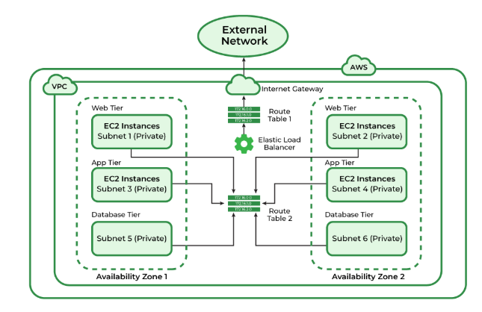
The provided diagram represents the working architecture of an Amazon Virtual Private Cloud (VPC), showcasing how various components are interconnected to create a secure and functional network environment. At its core, the VPC is a logically isolated segment of the AWS cloud that enables users to launch and manage resources with complete control over networking configurations. The architecture begins with the division of the VPC into multiple subnets, which are smaller segments of the network, organized across two Availability Zones (AZs) for high availability and fault tolerance. Each subnet serves a specific purpose, such as hosting web servers in the Web Tier, application servers in the App Tier, and databases in the Database Tier.
The flow of traffic within the VPC is governed by route tables, which define the rules for communication between subnets and external networks. For external communication, an Internet Gateway (IGW) is attached to the VPC, enabling public-facing resources in the Web Tier to interact with users or other systems outside the VPC. To ensure efficient traffic distribution, an Elastic Load Balancer (ELB) is positioned to direct incoming traffic from the external network to the appropriate EC2 instances in the Web Tier. Within the VPC, secure internal communication takes place between the Web Tier, App Tier, and Database Tier using private subnets and route tables. This architecture ensures logical isolation, scalability, fault tolerance, and secure communication between resources, making it a robust solution for hosting cloud applications.
VPC Components:
1. Subnets (Public vs. Private):
Subnets are subdivisions of a VPC that allow resources to be grouped and organized within specific IP address ranges.
- Public Subnets:
  - Directly accessible from the internet.
  - Typically used for resources like web servers or load balancers.
  - Require an Internet Gateway (IGW) to enable public access.
- Private Subnets:
  - Not directly accessible from the internet.
  - Used for sensitive resources such as databases or internal applications.
  - Internet access (if needed) is enabled via a NAT Gateway or NAT Instance.
2. Route Tables:
Route Tables define the rules for directing network traffic within a VPC.
- Each subnet is associated with a route table that determines how traffic is routed.
- Example Routes:
  - Local traffic within the VPC.
  - External traffic to the internet via an Internet Gateway.
  - Private subnet traffic to external networks via a NAT Gateway/Instance.
3. Internet Gateway (IGW):
An Internet Gateway is a horizontally scalable and highly available component that allows resources in public subnets to access the internet.
- Provides a pathway for traffic between the VPC and the internet.
- It is attached to the VPC and configured in the route table to enable outbound and inbound traffic for public subnets.
4. NAT Gateway & NAT Instance:
Both NAT Gateways and NAT Instances allow resources in private subnets to access the internet without exposing them directly to inbound traffic.
- NAT Gateway:
  - Fully managed, highly available, and scalable AWS service.
  - Requires minimal maintenance and is preferred for production environments.
- NAT Instance:
  - A manually configured EC2 instance used as a NAT.
  - Provides more control but requires management and scaling.
5. Elastic IP (EIP):
An Elastic IP is a static, public IPv4 address that you can allocate to your AWS account.
- Can be associated with EC2 instances, NAT Gateways, or other components.
- Enables persistent and consistent access to resources, even if the underlying resource is restarted or replaced.
6. Security Groups vs. Network ACLs:
Security Groups (SGs) and Network Access Control Lists (NACLs) are both used to secure resources, but they operate at different levels:
- Security Groups:
  - Operate at the instance level (attached to EC2 instances).
  - Stateful: Automatically allows return traffic for outbound requests.
  - Define rules for inbound and outbound traffic.
- Network ACLs:
  - Operate at the subnet level (apply to all instances in the subnet).
  - Stateless: Both inbound and outbound rules must be defined explicitly.
  - Useful for applying additional layers of security.
7. Peering Connections:
VPC Peering allows two VPCs to connect privately over AWS infrastructure.
- Enables resources in different VPCs to communicate as if they were in the same network.
- Can be established between VPCs in the same or different AWS accounts and regions.
- Does not support transitive peering (traffic cannot flow through a third VPC).
Networking Concepts:
1.CIDR (Classless Inter-Domain Routing):
CIDR (Classless Inter-Domain Routing) is a method for allocating IP addresses and routing IP traffic more efficiently.
- Introduced to replace the traditional Class A, B, and C IP addressing system, CIDR allows for more flexible subnetting.
- It uses a combination of an IP address and a subnet mask, written in the format IP_address/prefix_length.
  - The IP address identifies the network.
  - The prefix length (e.g., /16) specifies the number of bits used for the network portion of the address.
Example:
- CIDR Notation: 192.168.0.0/24
  - Network Portion: First 24 bits (192.168.0)
  - Host Portion: Remaining 8 bits (0.0 to 0.255)
  - Total Addresses: 2⁸ = 256 addresses (0 to 255)
Key Benefits of CIDR:
- Efficient IP address allocation.
- Enables the creation of smaller subnets within larger networks.
- Reduces waste of IP addresses.
2. Assigning IP Ranges in a VPC:
When creating a VPC, you define its IP address range using CIDR. This range determines the available IP addresses for subnets and resources within the VPC.
Steps to Assign IP Ranges:
- Select a CIDR Block:
  - AWS supports IP ranges from 10.0.0.0/8 to 192.168.0.0/16 for VPCs (non-overlapping private IP ranges).
  - Choose a block size appropriate for the number of IP addresses you need.
- Subnetting the VPC:
  - Divide the VPC CIDR block into smaller subnets using smaller CIDR blocks.
  - Each subnet must have a unique IP range within the VPC.
Example:
- VPC CIDR Block: 10.0.0.0/16 (65,536 IP addresses)
  - Subnet 1 (Public): 10.0.0.0/24 (256 IPs)
  - Subnet 2 (Private): 10.0.1.0/24 (256 IPs)
  - Subnet 3 (Private): 10.0.2.0/24 (256 IPs)
- Allocate IPs to Resources:
  - Assign public or private IPs to instances, load balancers, or NAT Gateways within the defined subnets.
3. Private vs. Public IP Addresses
AWS uses private IP addresses and public IP addresses for networking resources.
Private IP Addresses:
- Private IPs are used for internal communication within a VPC.
- They are not accessible directly from the internet.
- Private IP ranges (RFC 1918):
  - 10.0.0.0 – 10.255.255.255
  - 172.16.0.0 – 172.31.255.255
  - 192.168.0.0 – 192.168.255.255
Example:A database server in a private subnet might be assigned the private IP 10.0.1.10 to communicate with an application server in the same VPC.
Public IP Addresses:
- Public IPs are used for resources that need direct access to the internet.
- These are unique, globally routable IPs assigned to instances in public subnets.
- AWS assigns public IPs automatically or allows Elastic IPs (static public IPs).
Example:A web server in a public subnet might have a public IP 203.0.113.25, enabling access from users over the internet.
Use Cases of AWS VPC:
AWS VPC provides a secure, scalable, and customizable cloud networking environment. Below are some common use cases:
1. Hosting Web Applications:
- Use public subnets to host web servers that handle user requests and traffic.
- Place backend databases and application servers in private subnets to ensure restricted access.
- Secure communication between tiers using security groups and NACLs.
Example:A web application with a frontend in public subnets and backend services like databases in private subnets.
2. Hybrid Cloud Connectivity:
- Extend on-premises networks to the AWS cloud using a VPN or AWS Direct Connect.
- Use VPC Peering or a Transit Gateway to enable secure communication between on-premises and cloud environments.
Example:A company running workloads both on-premises and in the cloud can seamlessly integrate their environments for unified operations.
3. Disaster Recovery:
- Replicate critical data and applications in a separate VPC within a different region or Availability Zone.
- Ensure redundancy and high availability by replicating environments using Elastic Load Balancers, Auto Scaling Groups, and Route 53 failover policies.
Example:A business can set up a secondary VPC in another region to quickly recover operations in case of data center failure.
4. Secure Big Data and Analytics:
- Use private subnets to deploy big data and analytics services like Amazon EMR or Redshift securely.
- Prevent external access while enabling internal communication between data processing and storage systems.
Example:Analyzing sensitive customer data in a VPC with no direct internet access for enhanced data privacy.
5. Multi-Tier Architecture:
- Build a multi-tier application by separating layers (e.g., frontend, application logic, and database) into different subnets.
- Enhance security by restricting access between tiers using security groups and NACLs.
6. Secure API Backends:
- Host APIs within private subnets to restrict access while allowing communication with authorized applications.
- Use NAT Gateways to provide outbound internet connectivity for pulling updates or communicating with external APIs.
Example:An API backend for a mobile application securely hosted within a private VPC.
7. Isolated Environments for Testing and Development:
- Create a VPC for development and testing environments, completely isolated from production systems.
- Use VPC Peering for selective sharing of data between test and production environments.
Example:Developers can test new features in a sandbox environment without impacting live users.
8. Compliance and Regulatory Requirements:
- Meet regulatory standards like HIPAA, GDPR, and PCI-DSS by hosting workloads in isolated VPCs.
- Control data flow with strict security measures like encryption, monitoring, and IAM policies.
Example:A healthcare company uses a VPC to securely store and process patient health data in compliance with HIPAA.
9. Machine Learning and AI Workloads:
- Deploy ML/AI models on GPU-enabled EC2 instances within VPCs.
- Use private subnets for training models and public subnets for exposing APIs for inference.
Example:Training a predictive model in a secure VPC environment and serving results via a public-facing API.
Creating Custom VPC:
Step 1: Search for VPC from Management Console.
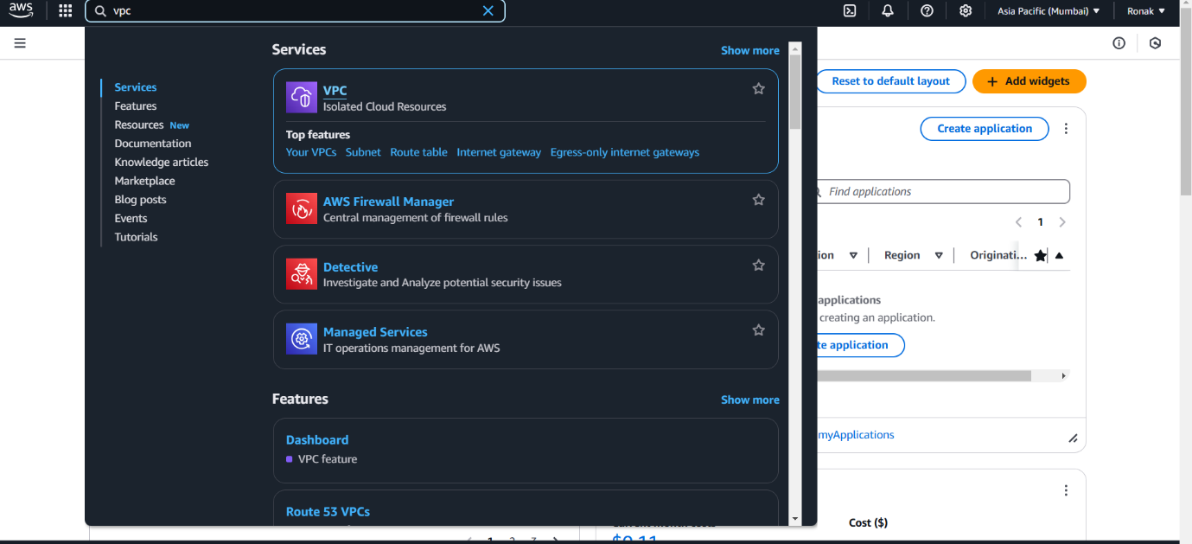
Step 2: Now, this Dashboard will appear and click on Create VPC.
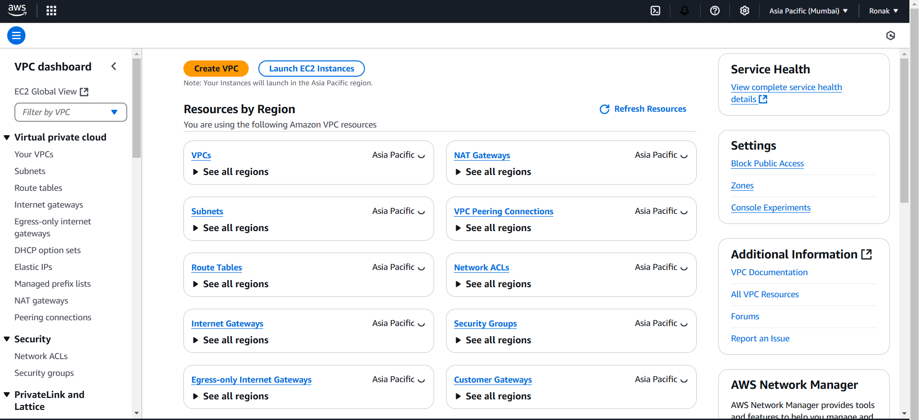
Step 3: Now, select the options as listed or as per your choice and at the bottom click on Create VPC.
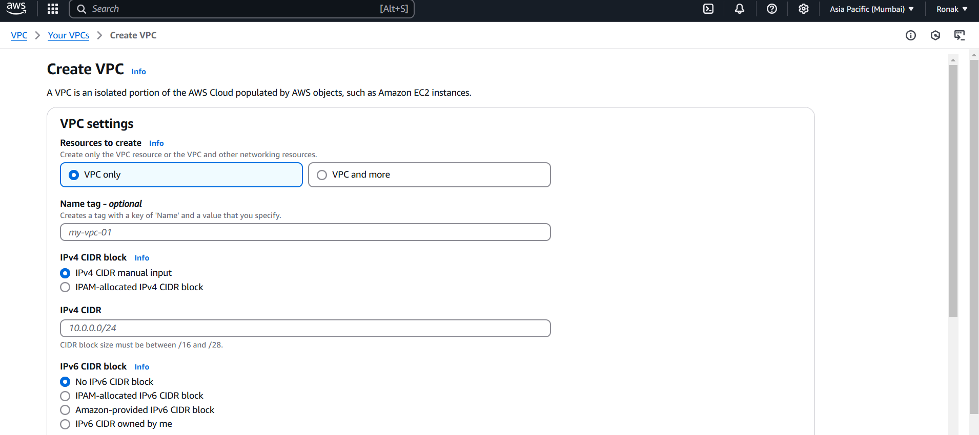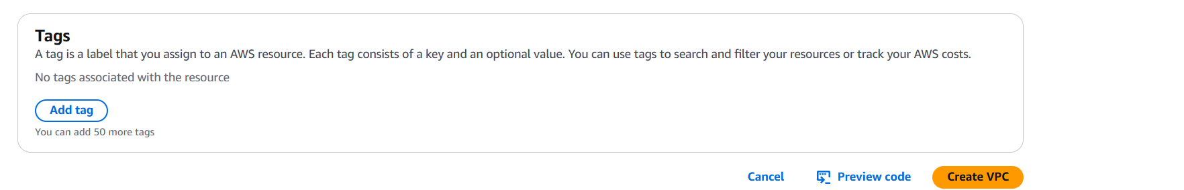
Step 4: Now, a VPC is created and this dashboard related to the details will be displayed like this.
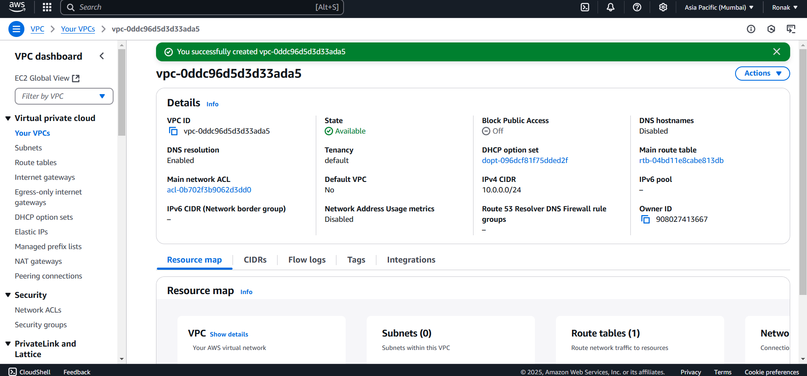
Step 5: Now, to add components of VPC, go to Subnets option and click on Create Subnet and then select the VPC to which you want to add this Subnet and all the other details and then click on Create Subnet.
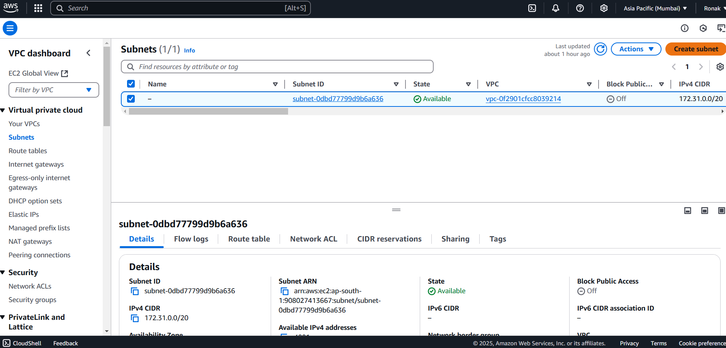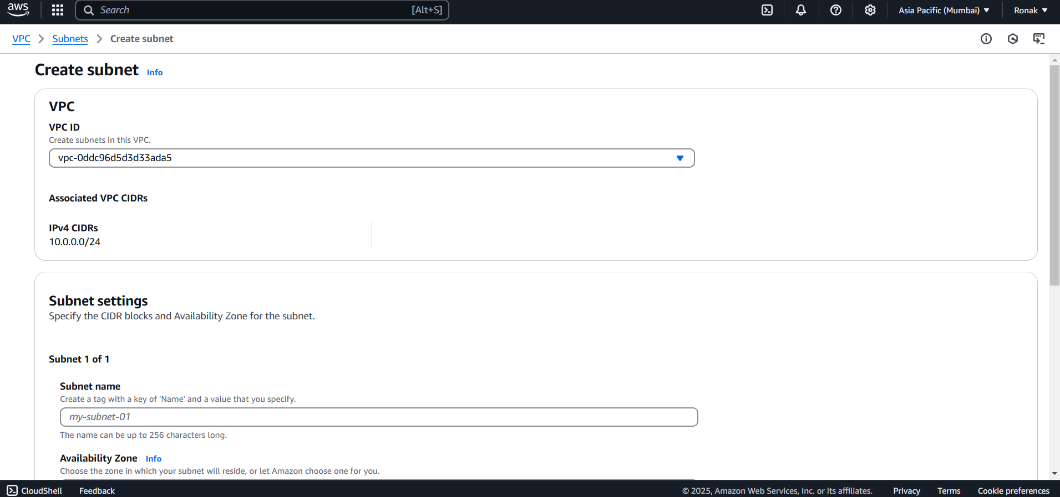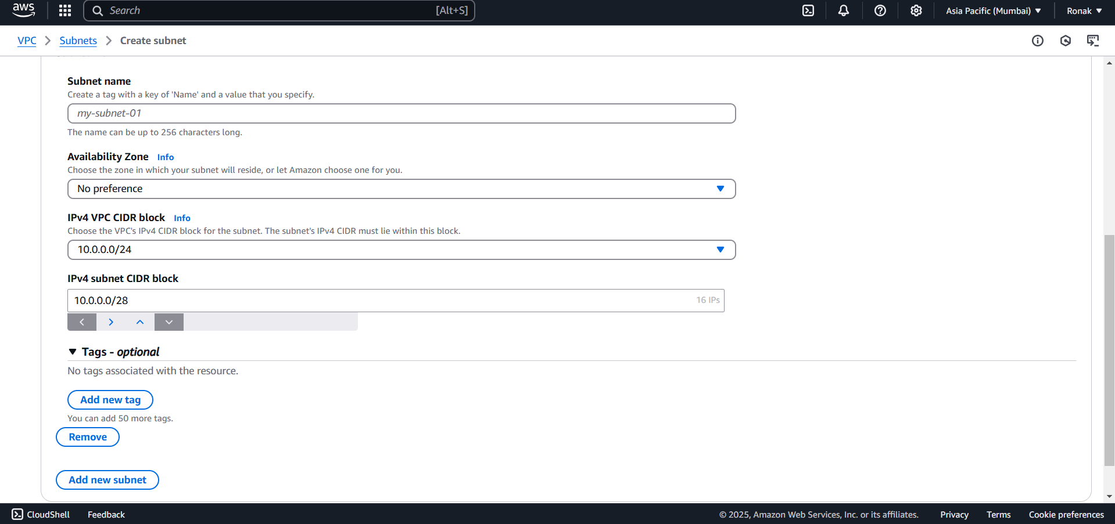
Step 6: Now, go to Route Table and click on Create Route Table and select VPC and create Route Table.
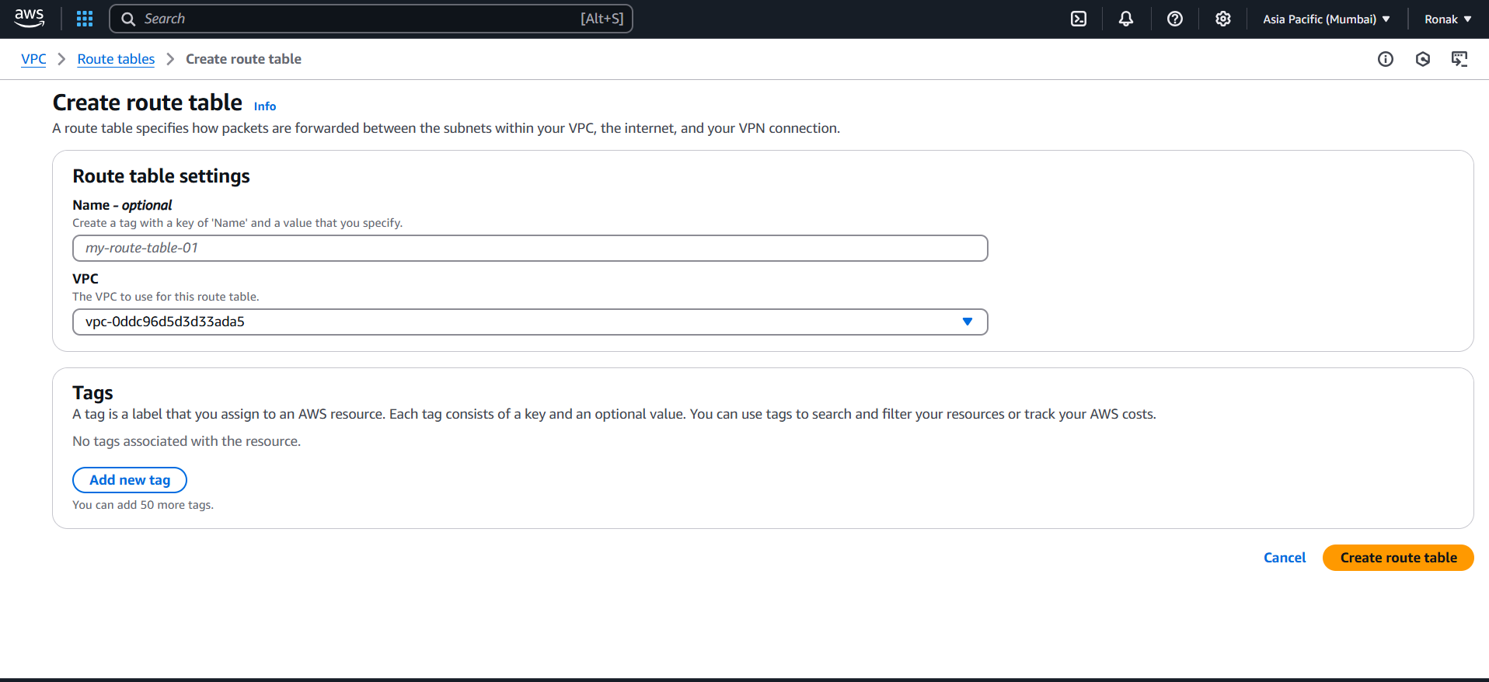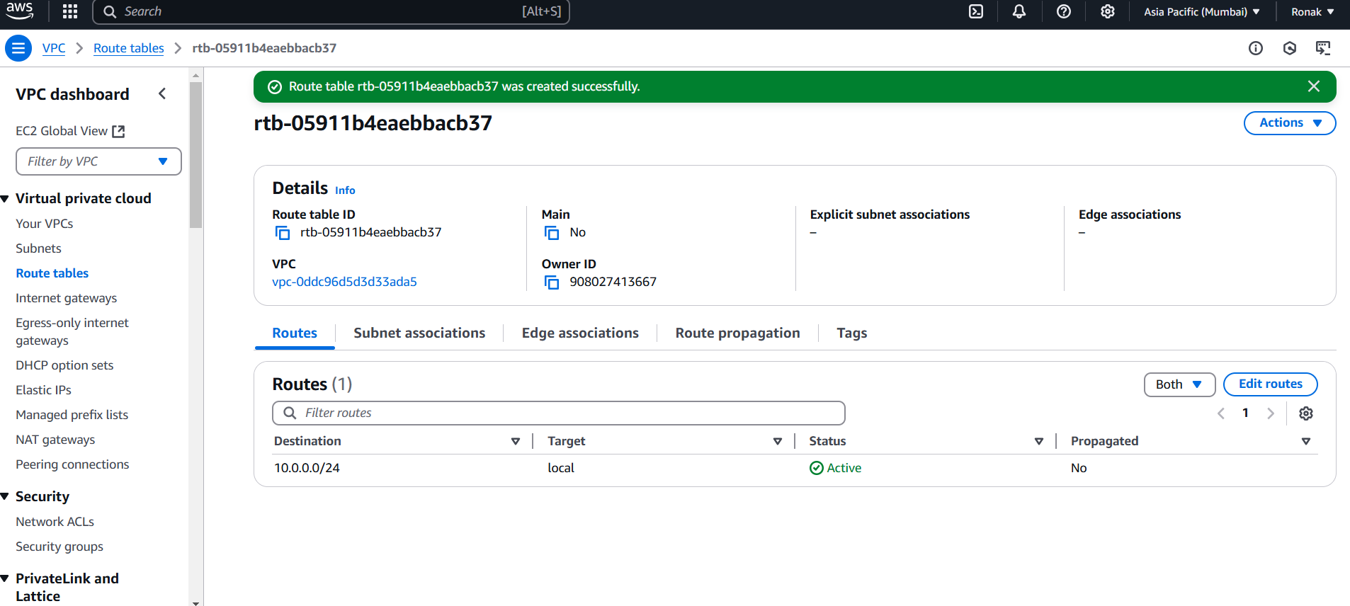
Step 7: Similarly, you can add each and every component from this VPC Dashboard and you can also launch EC2 instances in Public and Private Subnets.
